Cloud SQL

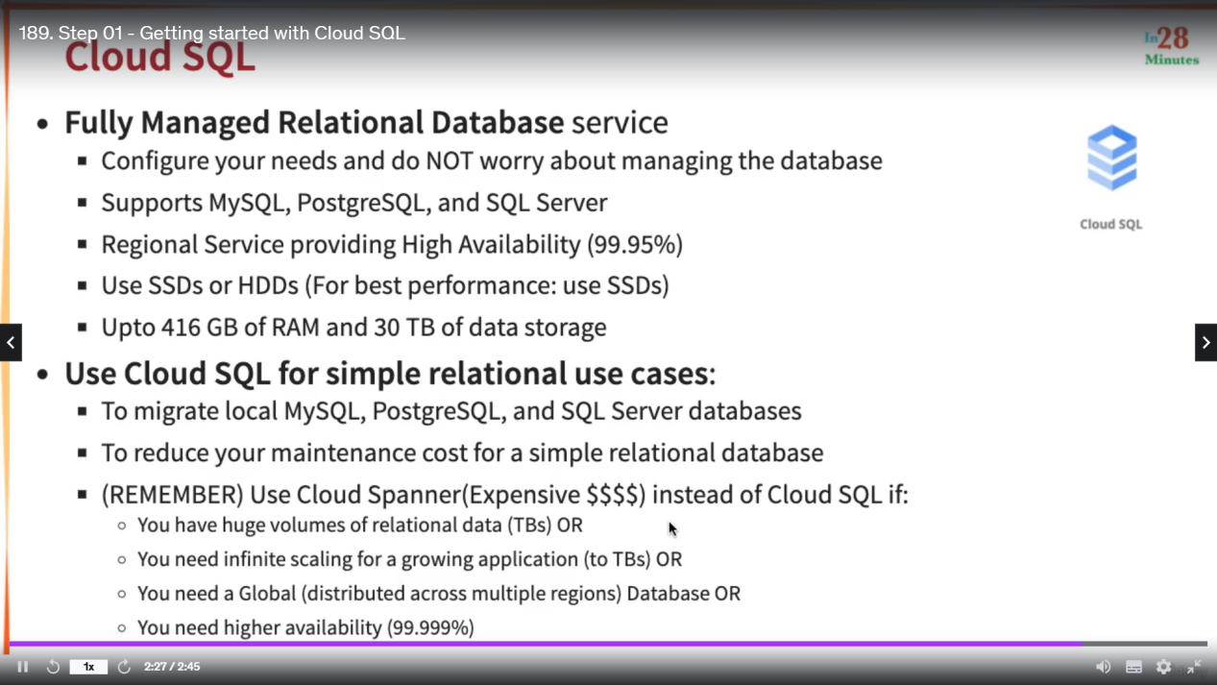

1. # Cloud SQL
2. gcloud sql connect my-first-cloud-sql-instance --user=root --quiet
3. gcloud config set project glowing-furnace-304608
4. gcloud sql connect my-first-cloud-sql-instance --user=root --quiet
5. use todos
6. create table user (id integer, username varchar(30) );
7. describe user;
8. insert into user values (1, 'Ranga');
9. select \* from user;
11. # Cloud Spanner
12. CREATE TABLE Users (
13. UserId INT64 NOT NULL,
14. UserName STRING(1024)
15. ) PRIMARY KEY(UserId);

18. # Cloud BigTable
19. bq show bigquery-public-data:samples.shakespeare
21. gcloud --version
22. cbt listinstances -project=glowing-furnace-304608
23. echo project = glowing-furnace-304608 > ~/.cbtrc
24. cat ~/.cbtrc
25. cbt listinstances

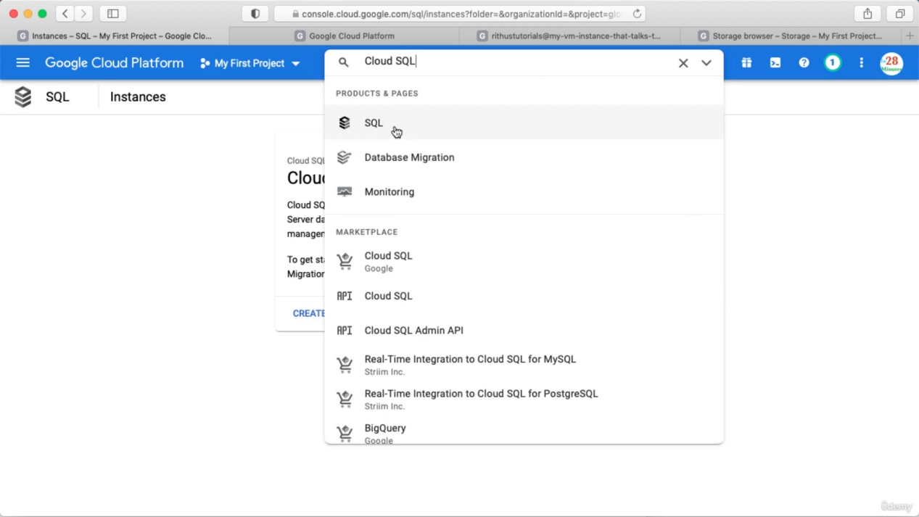

Click SQL=> Click create instance => you have to choose the db type

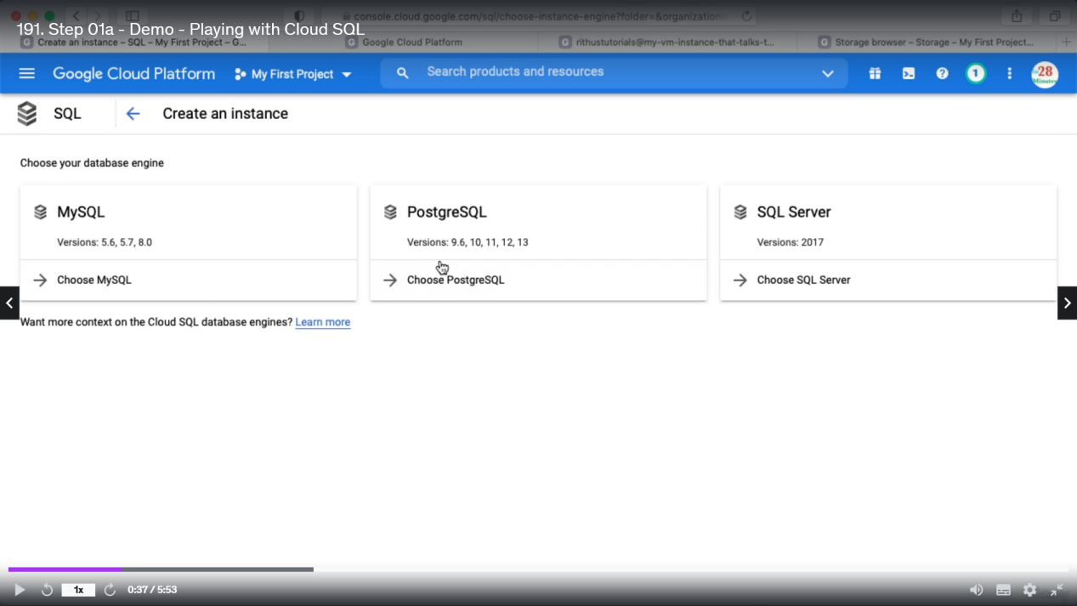

We need to fill below details

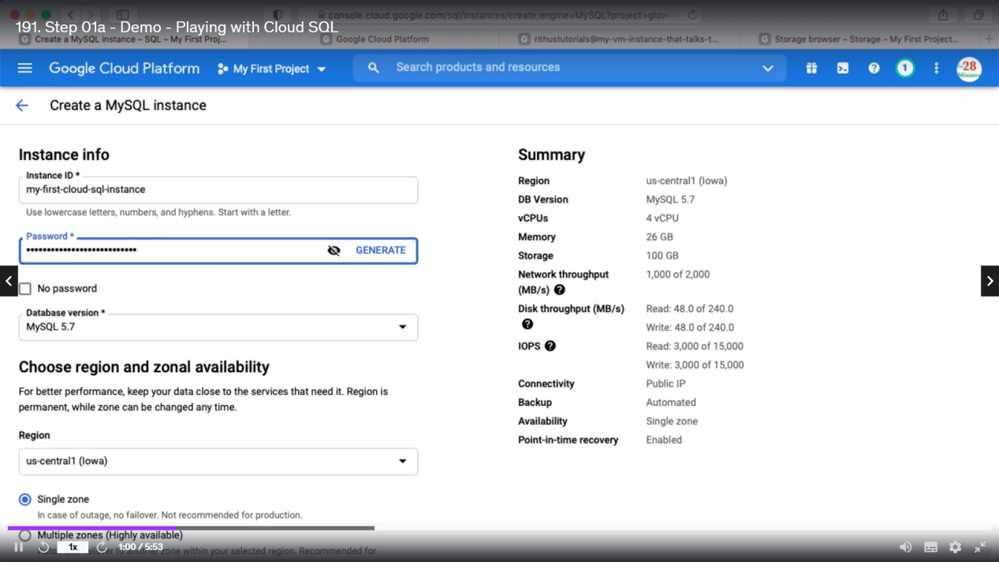

Keep rest of the things default. Click create instance. You can not create global instance for cloud SQL.

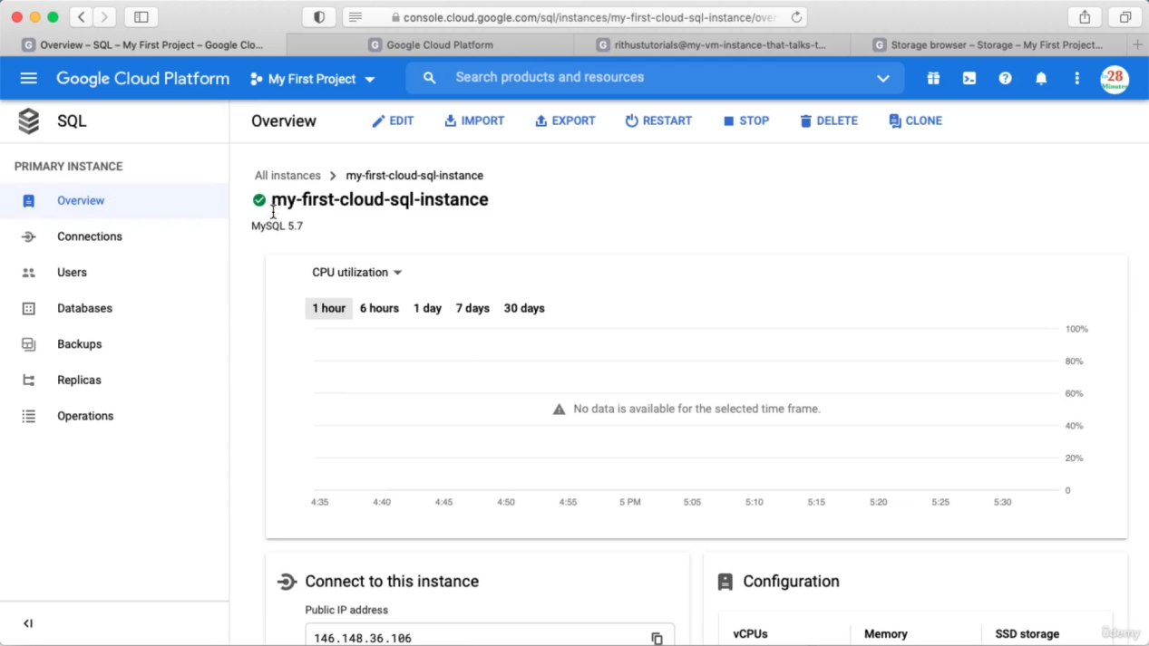

Now click database to create a database

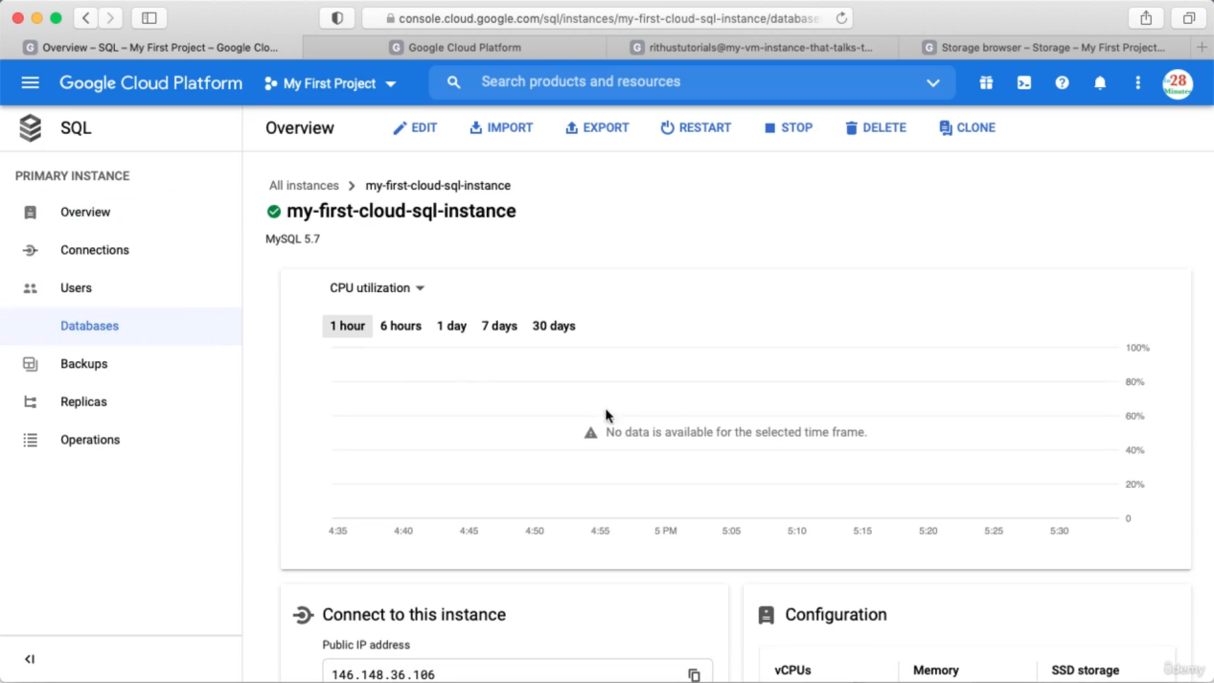

So, inside cloud sql instance we are creating database

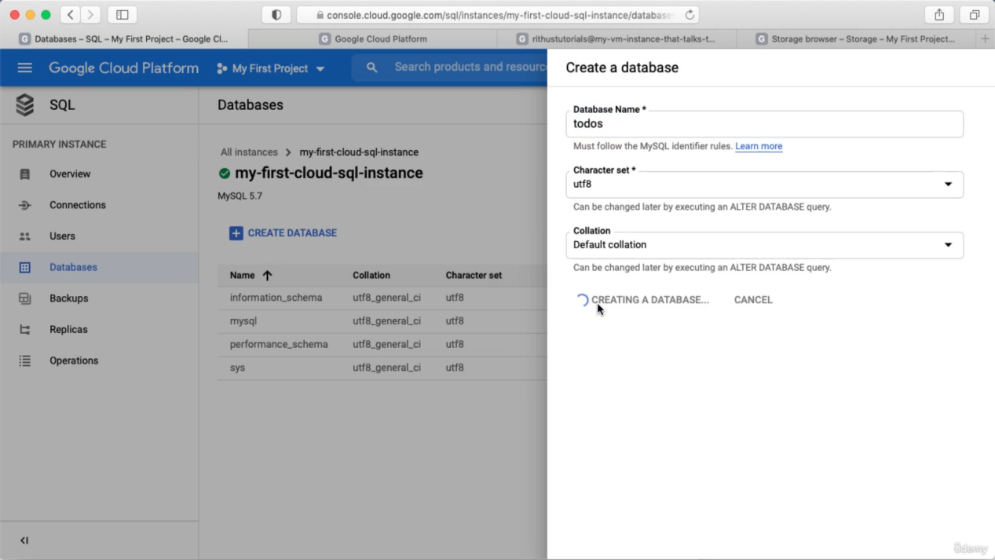

We can see some of the default databases here.

Connecting to DB

Go to overview => scroll a bit below and we can see options to connect with the database

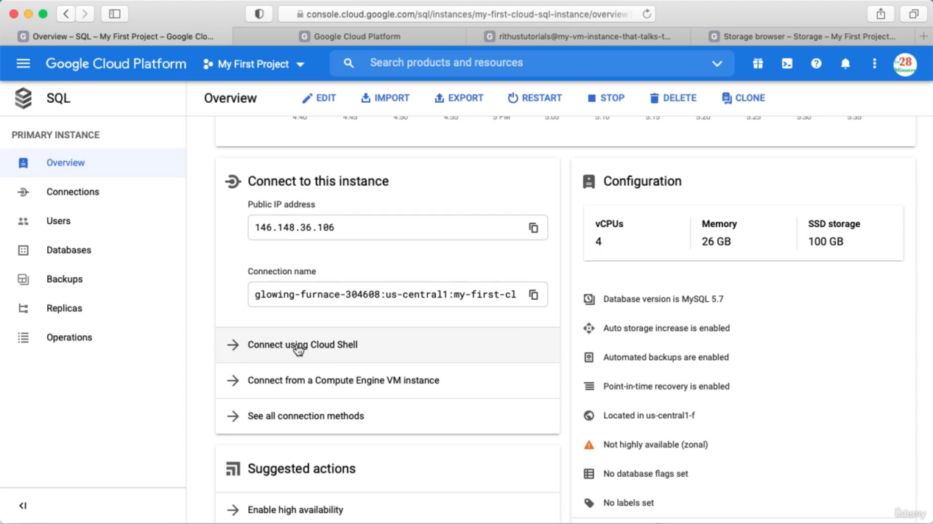

Click connect using cloudshell. We can see a default command and click enter

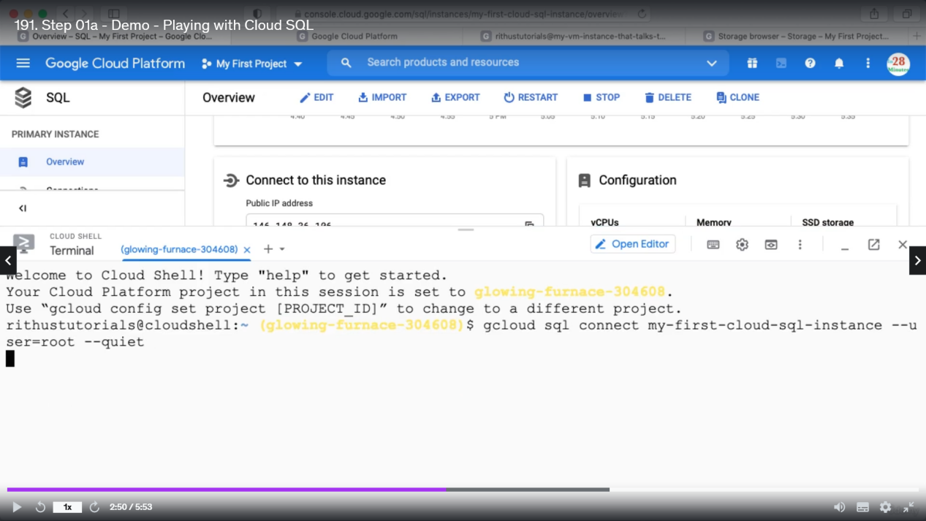

You will see below error => click on the link in the error and enable cloud SQL admin API

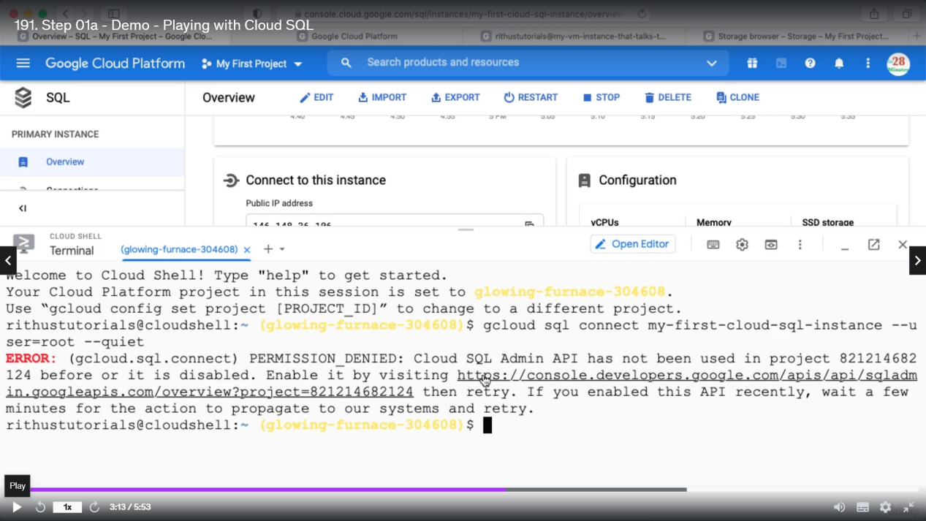

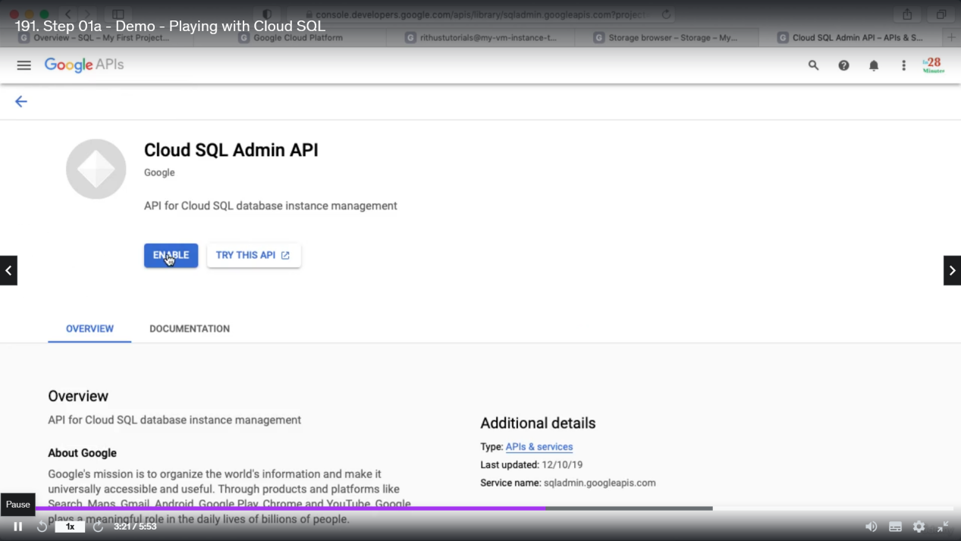

Now re-execute the command and enter the password and we can enter to the database

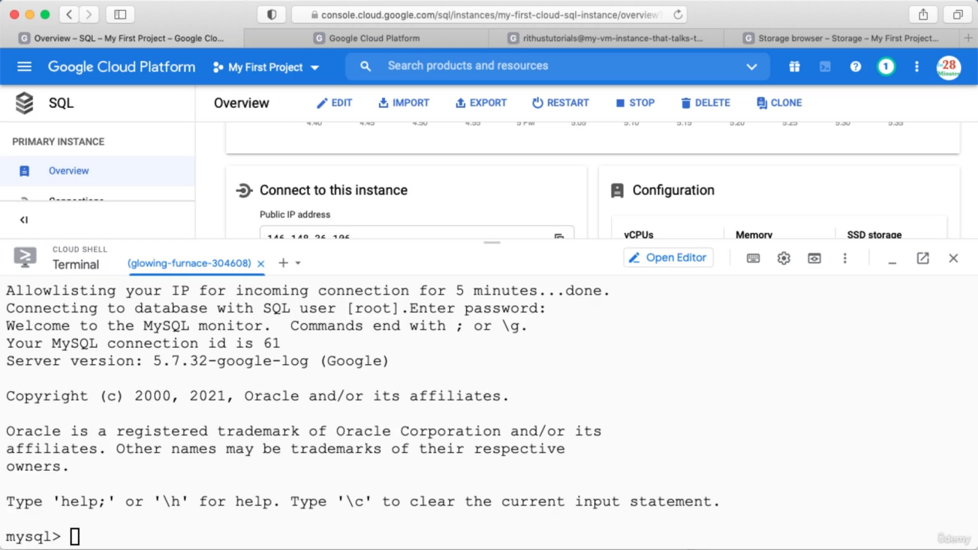

We can now use our db and create tables

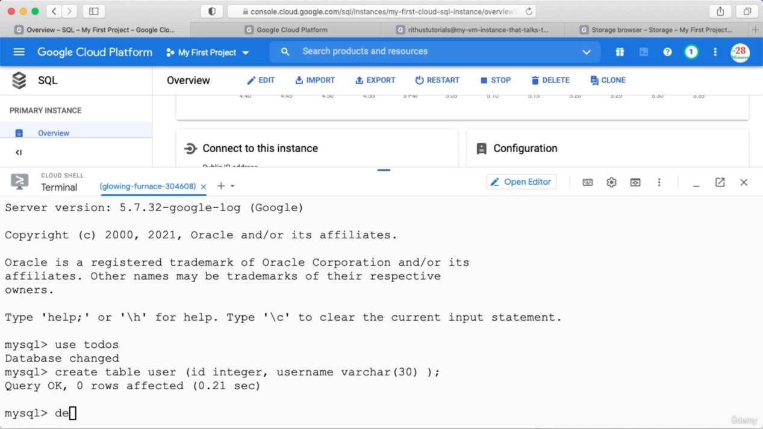

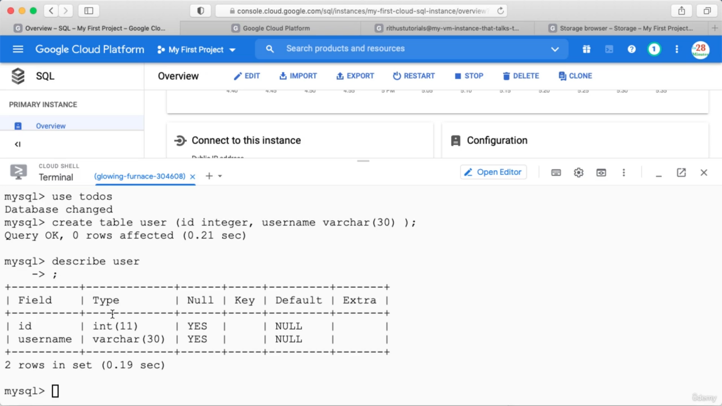

Exploring Cloud SQL

Using public IP we can connect to this DB from outside.

We can check each TAB below and explore

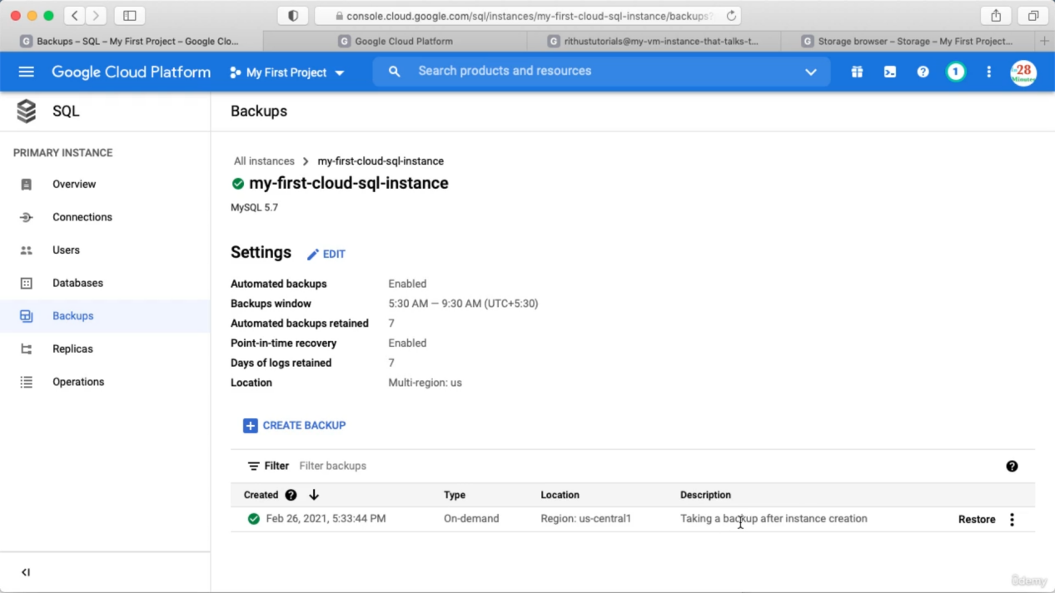

You can create a read replica in the same region or in different region.

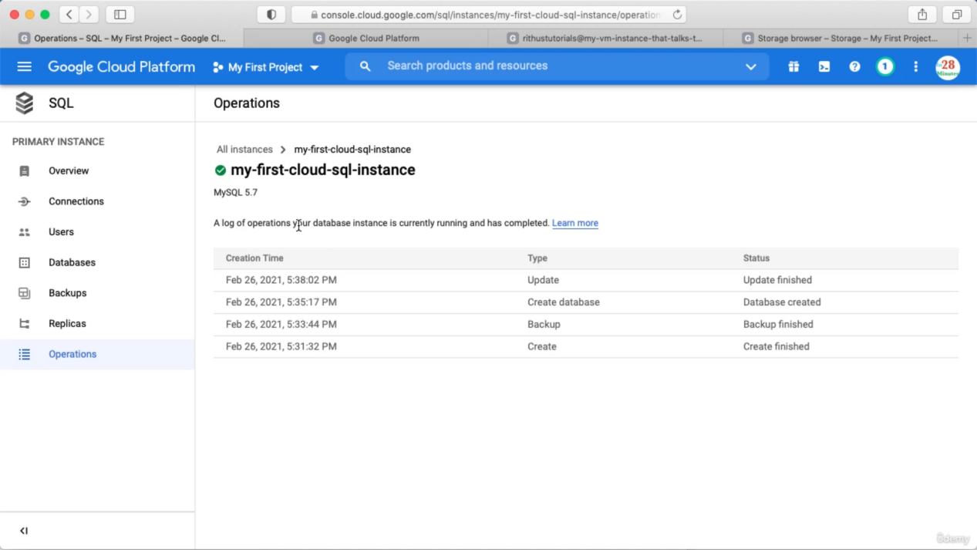

In operations we can see log of different operations that are performed.

Editing Details

Go to overview and click edit => check different options.

Delete instance

Click All instances

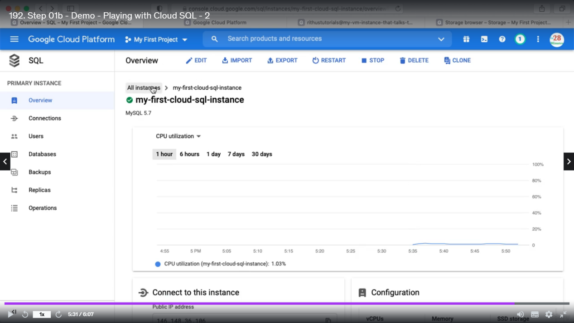

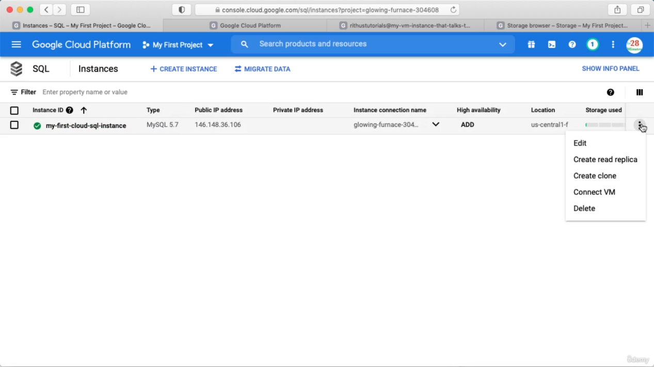

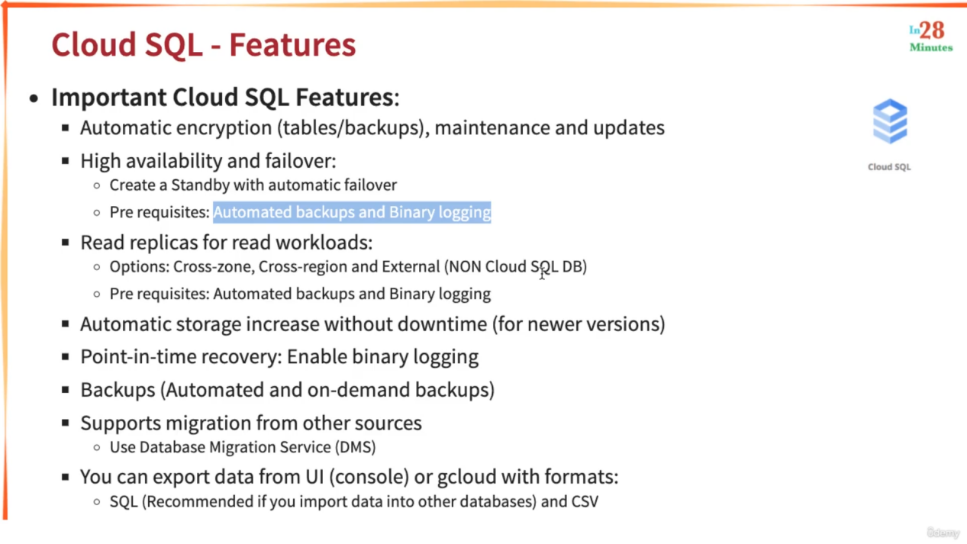

For getting high availability we can create a standby database with automatic failover.

Read replicas External means we can create on-premises replicas as well.

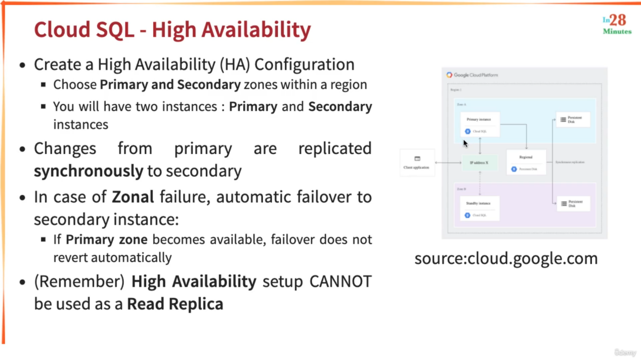

(Remember) => you can not connect to stand by db when primary db is alive. When primary is down only then we can connect to secondary. When primary is up again we can not automatically switch to primary. It is a manual process.

Next DB | Cloud Spanner

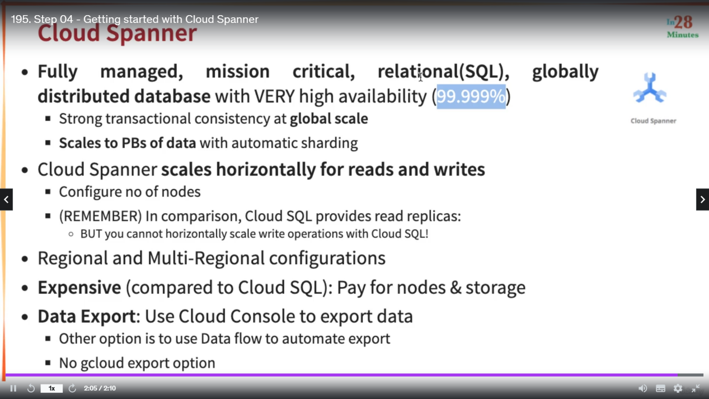

Search for cloud spanner and you can enable the API

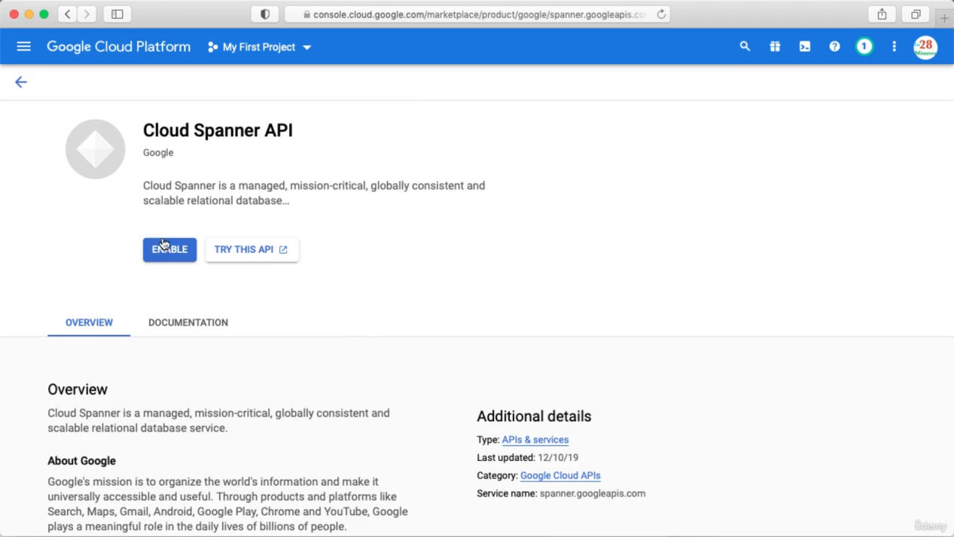

Here also you need to create a instance before creating the database

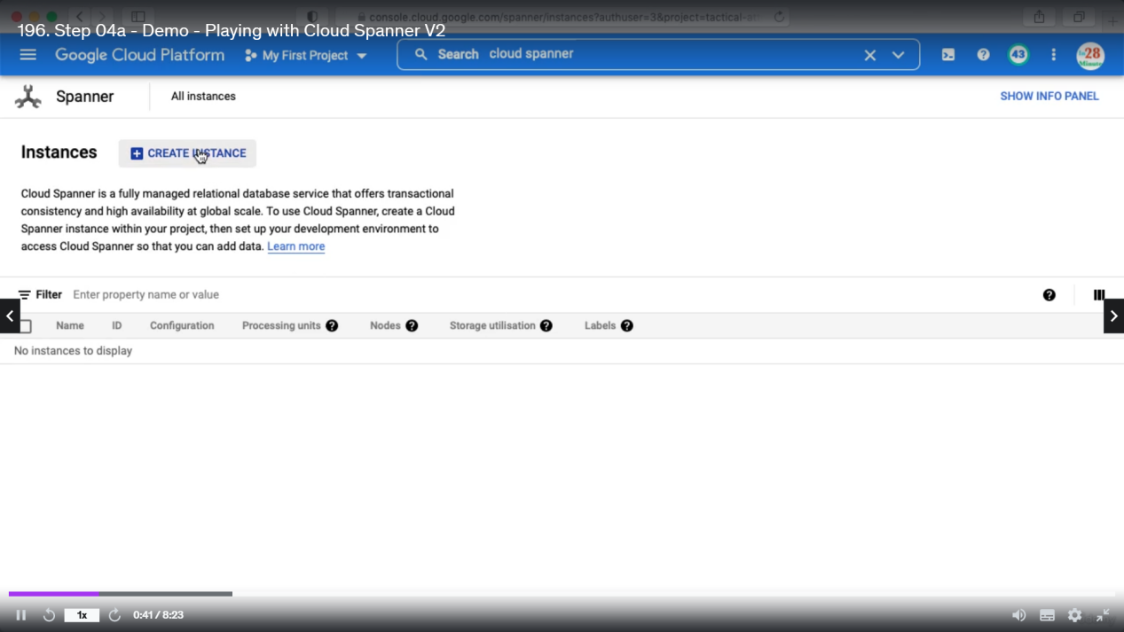

Add below details

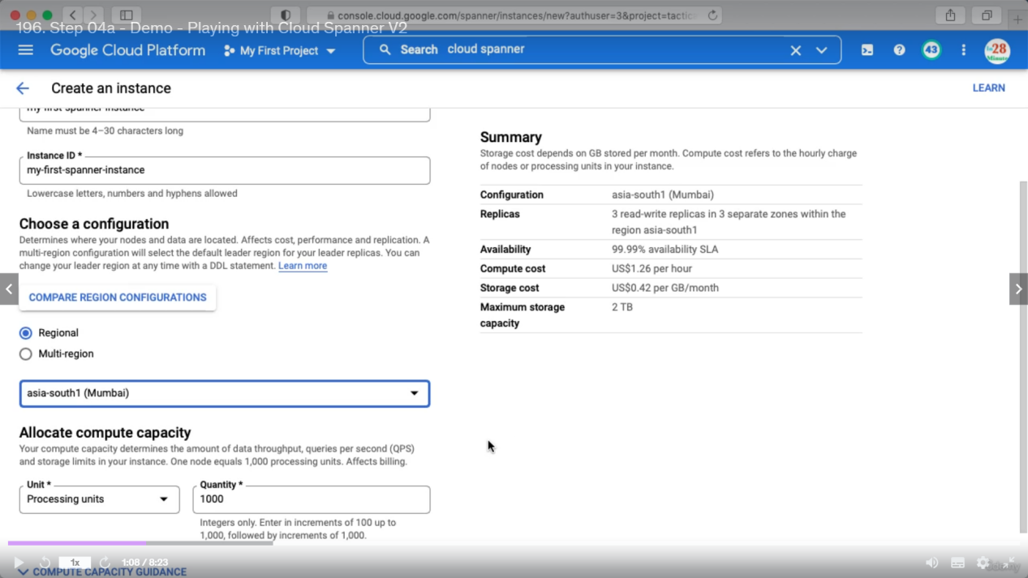

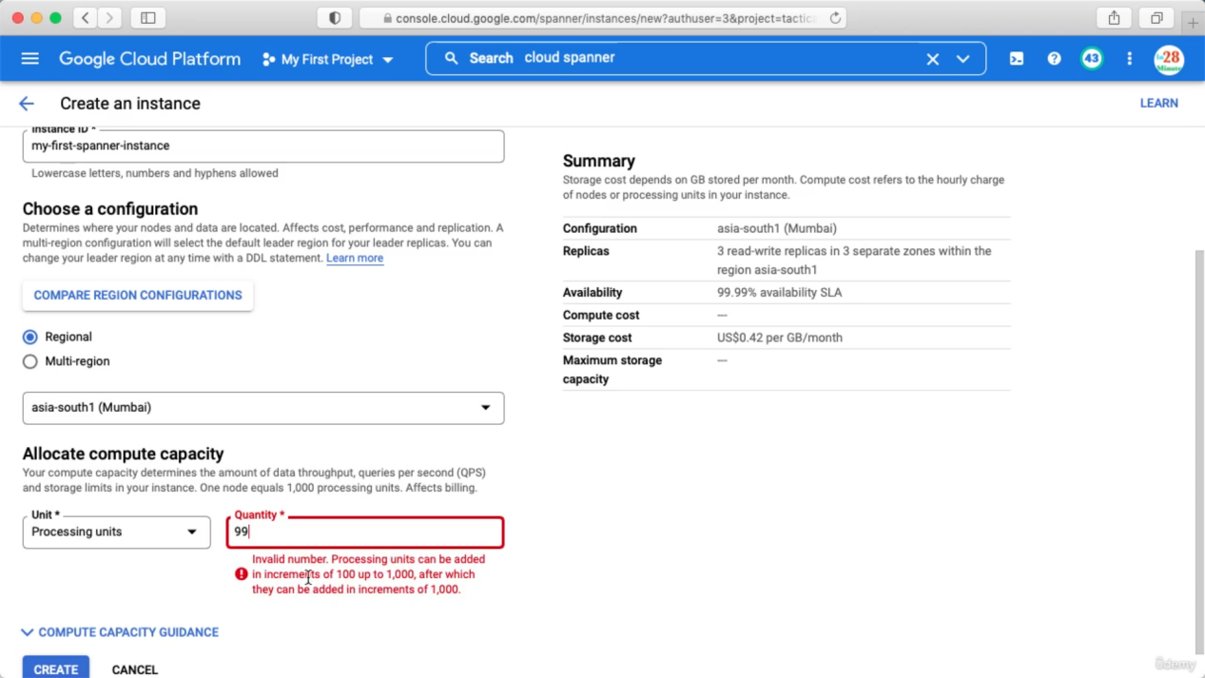

1 node = 1000 processing units. This will affect billing. Previously minimum we need to define one node.

After creating instance will look like below and now we can create our database

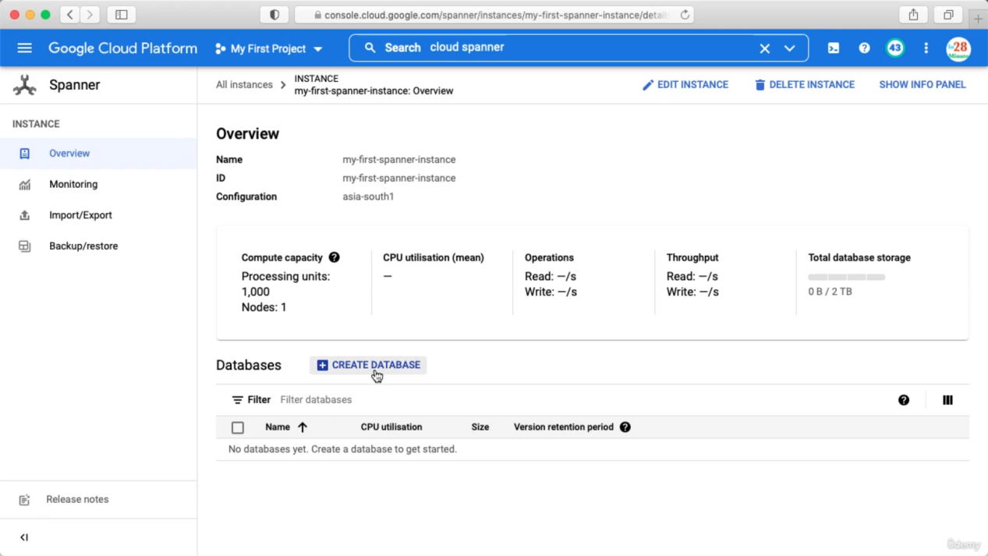

Give a name and click create. Inside DB we can create tables

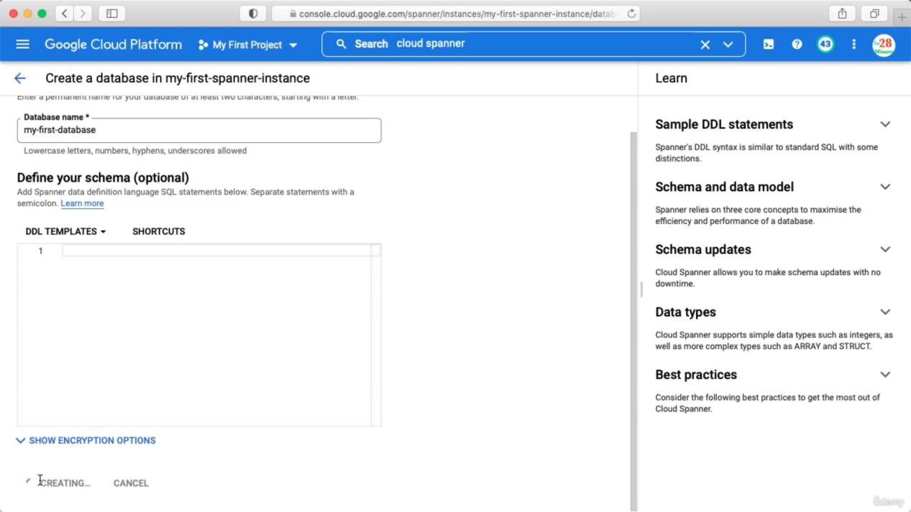

Creating table

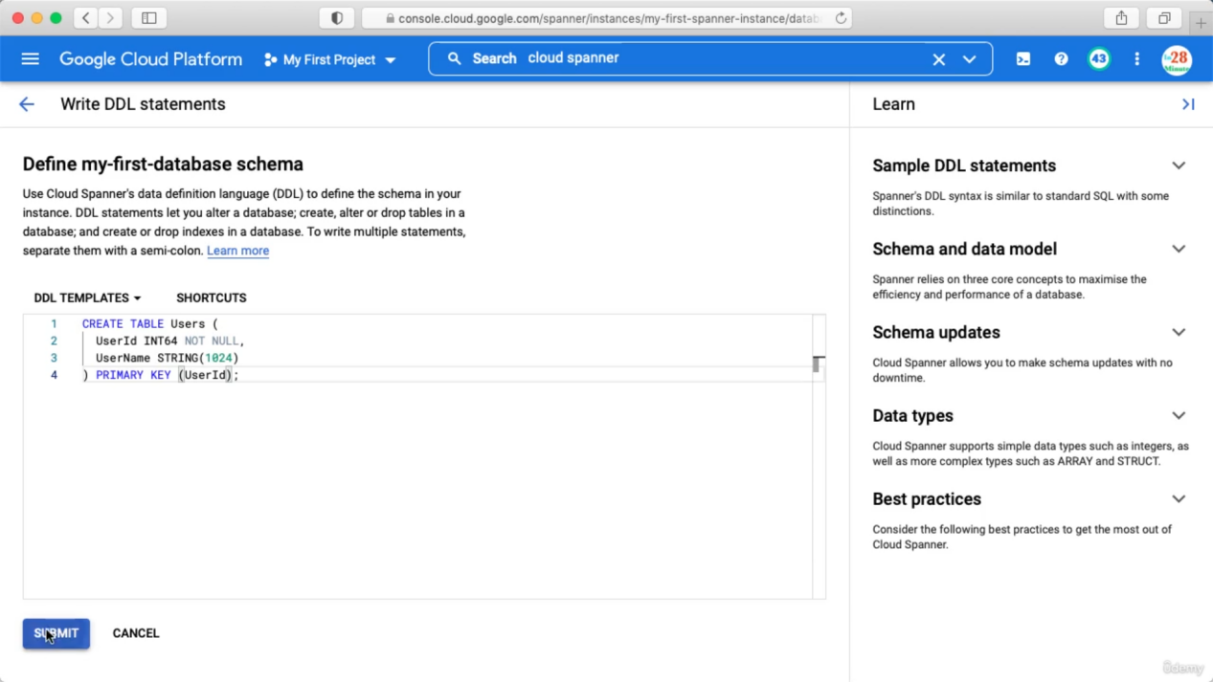

Insert data

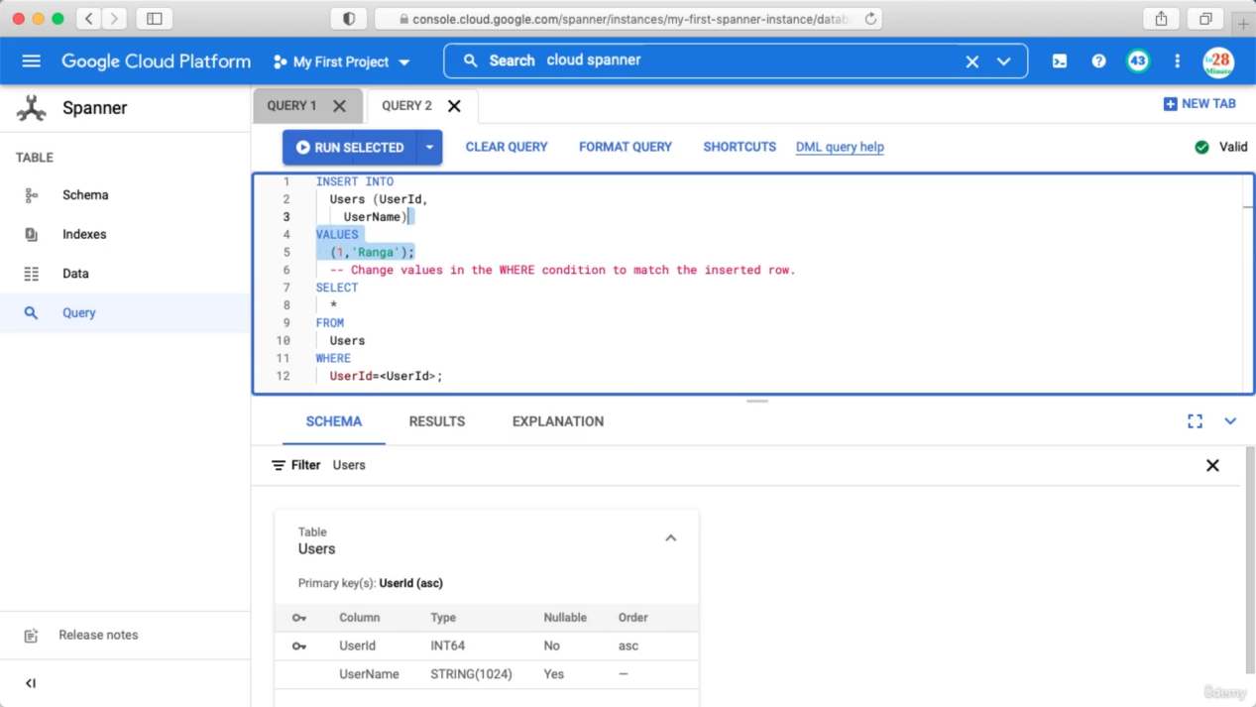

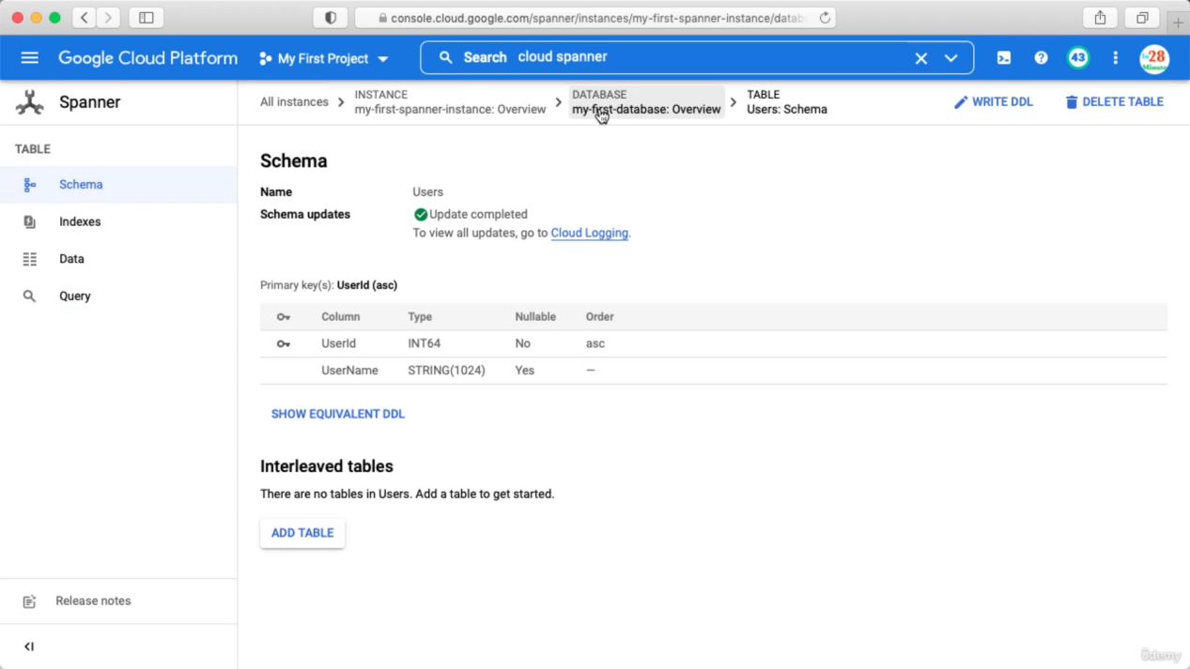

Go to Schema => Database Overview

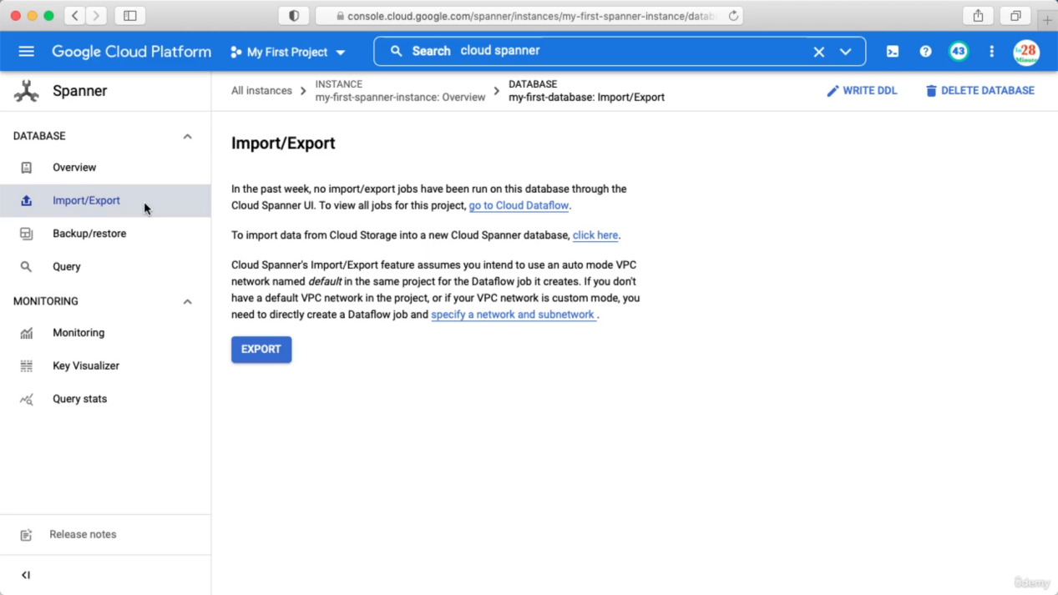

Here you can import or export data.

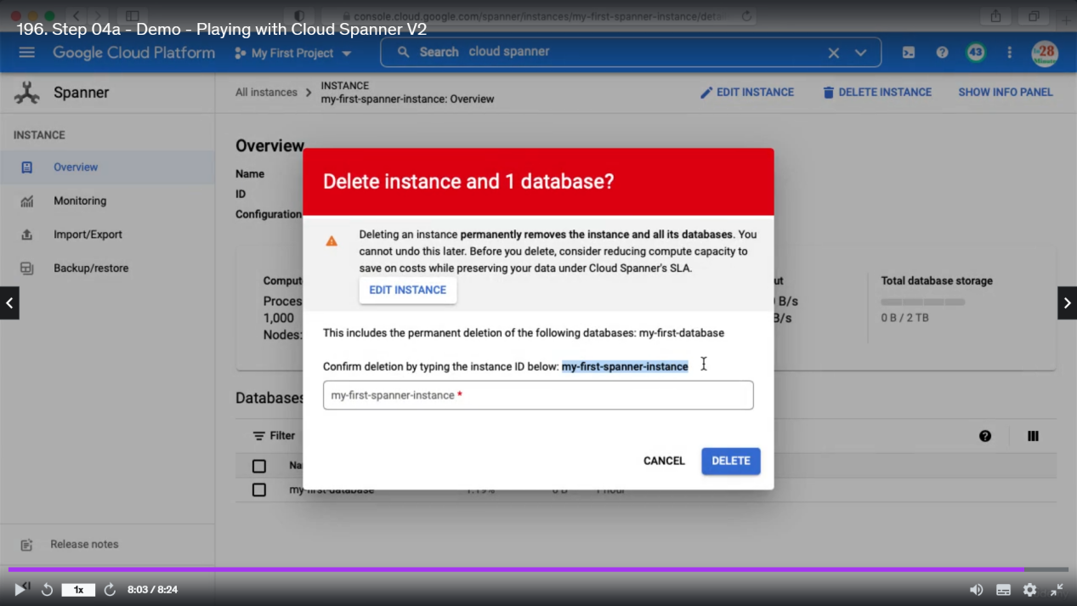

Memory Store

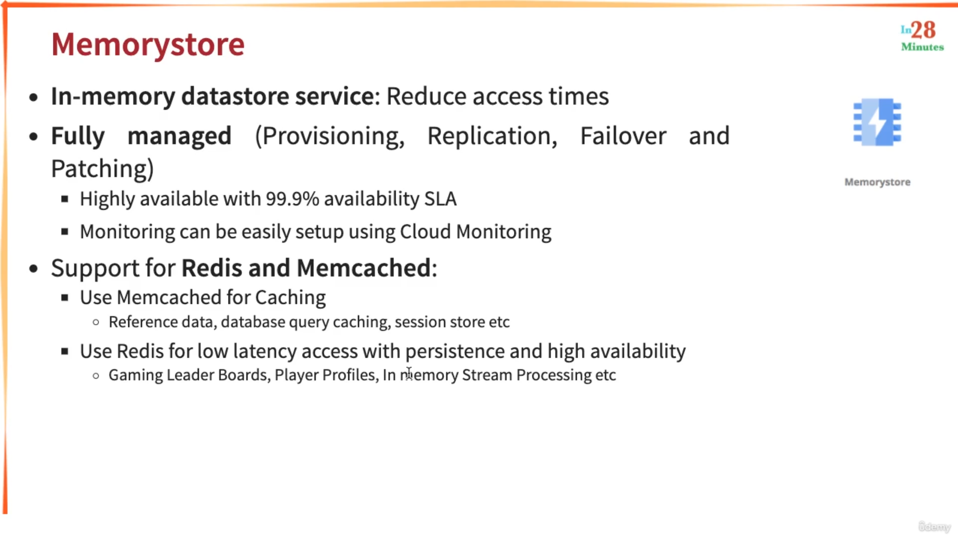

Memcached : if you are looking for pure caching otherwise go for redis.

Search : Memory

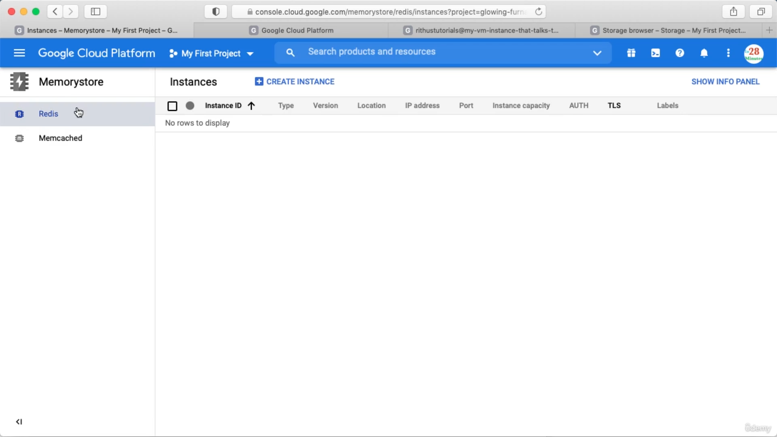

You can click create instance and store data.

Big Query

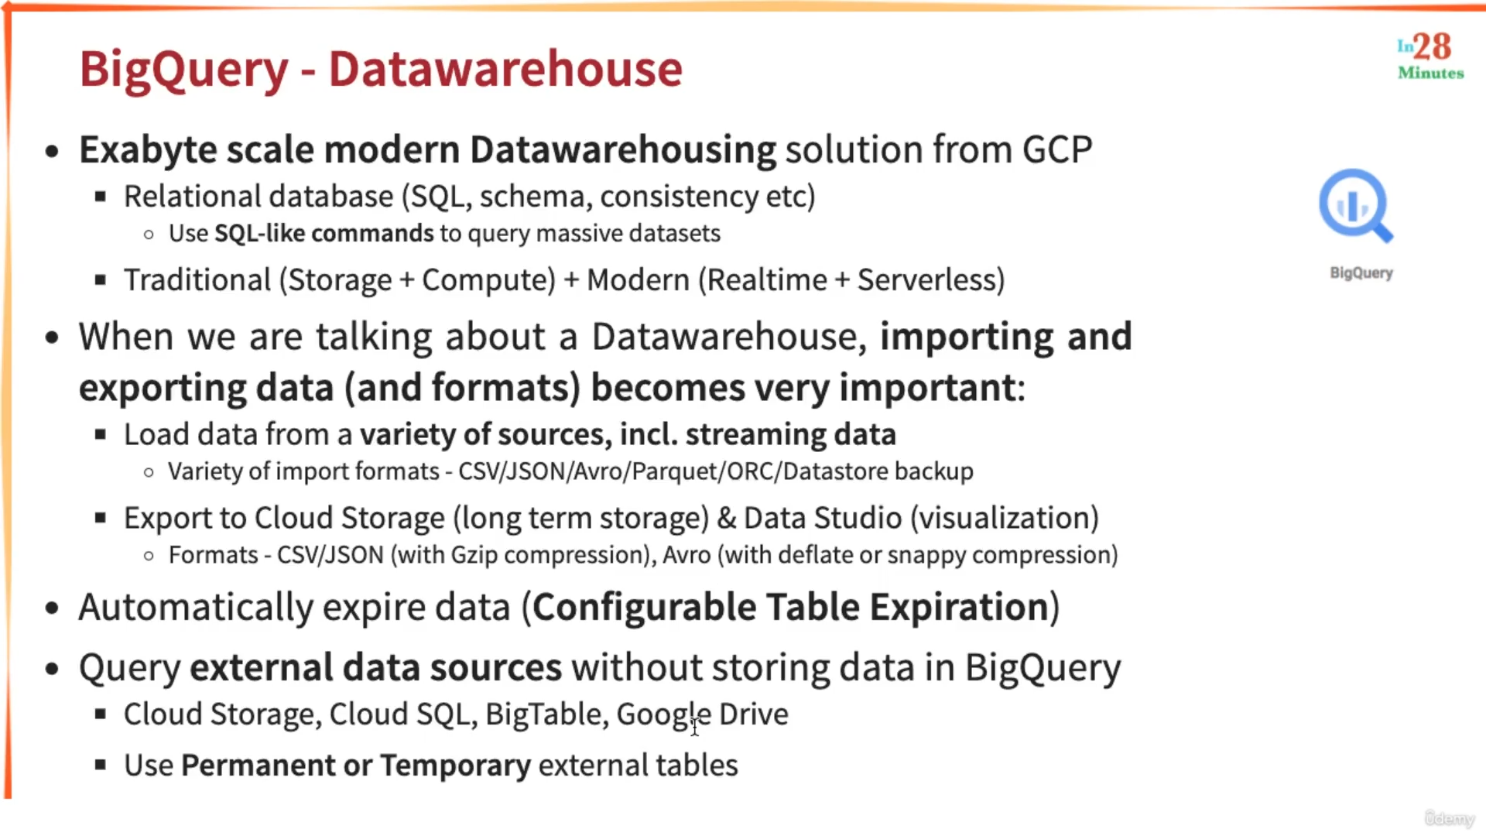

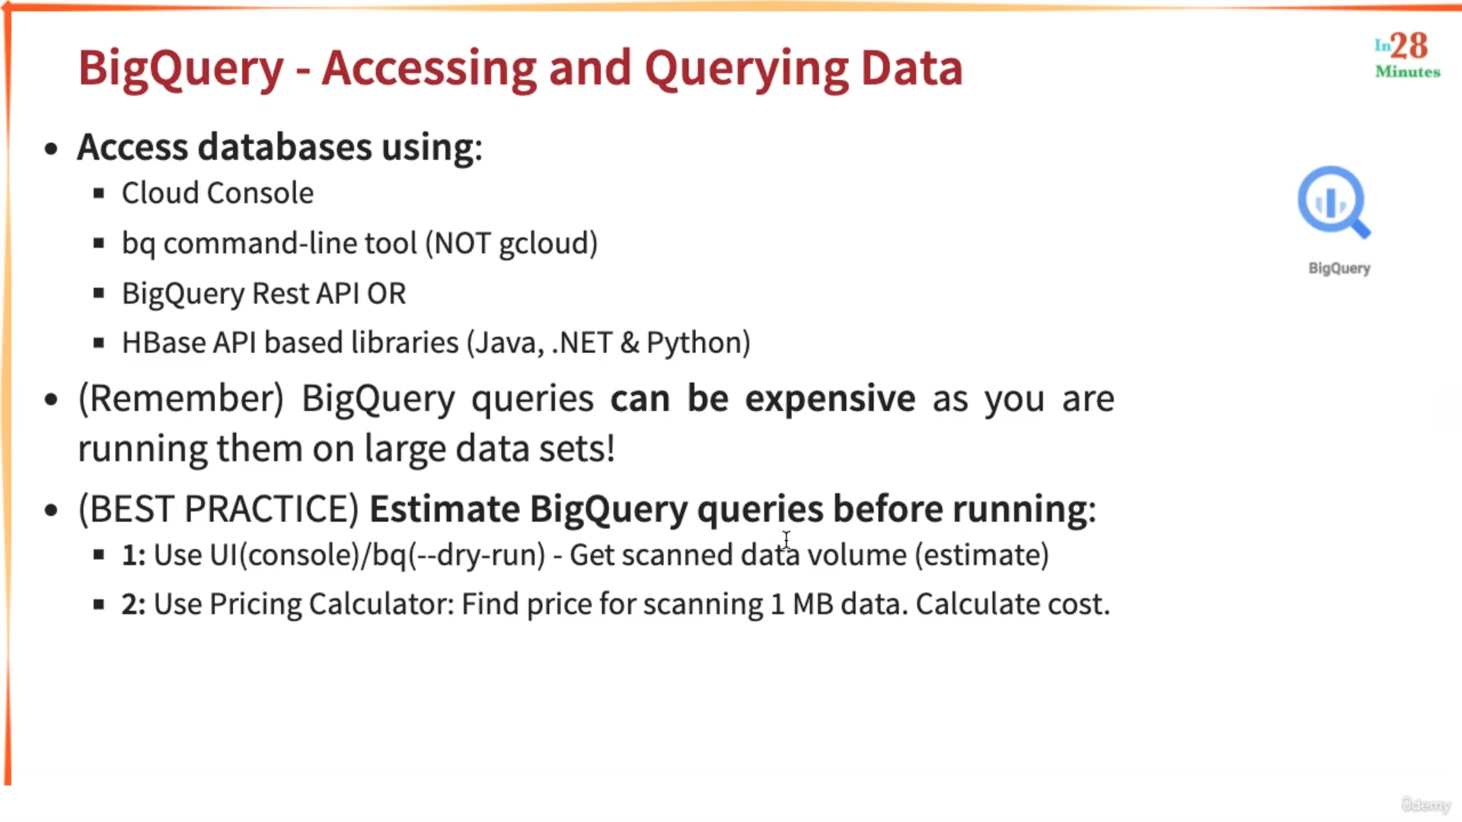

DB from command Line

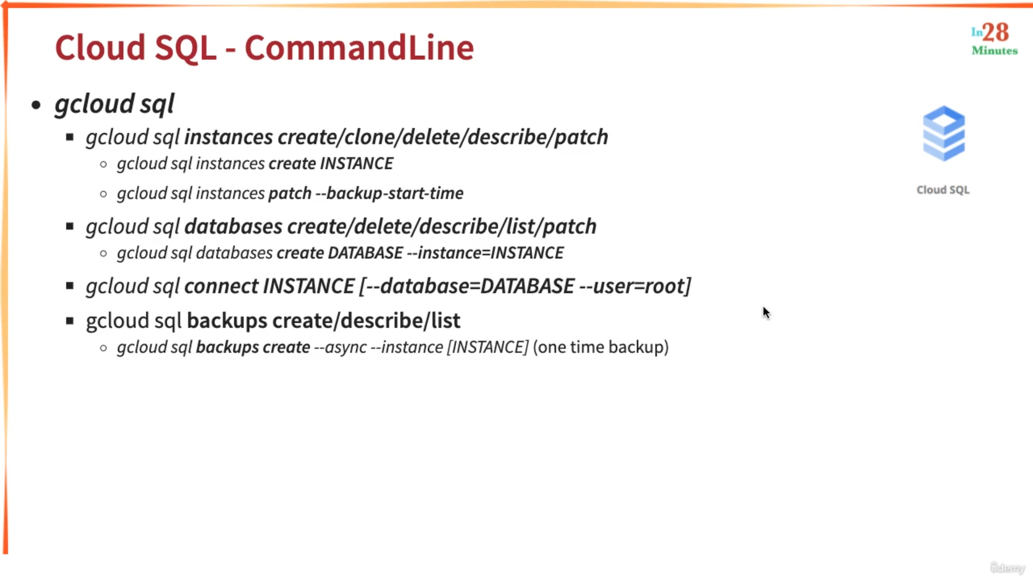

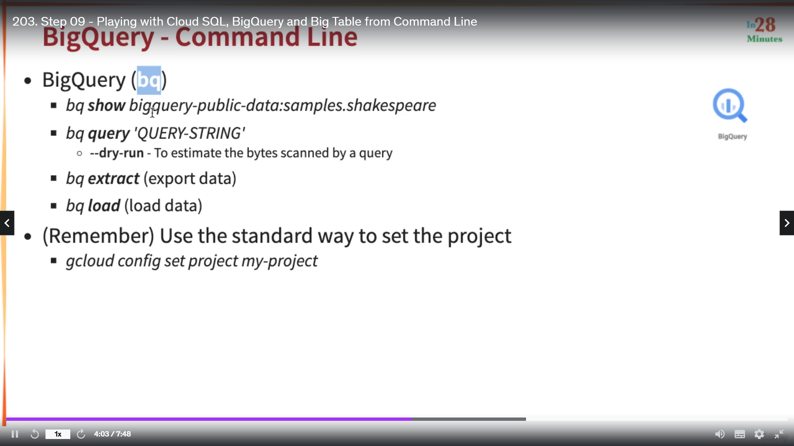

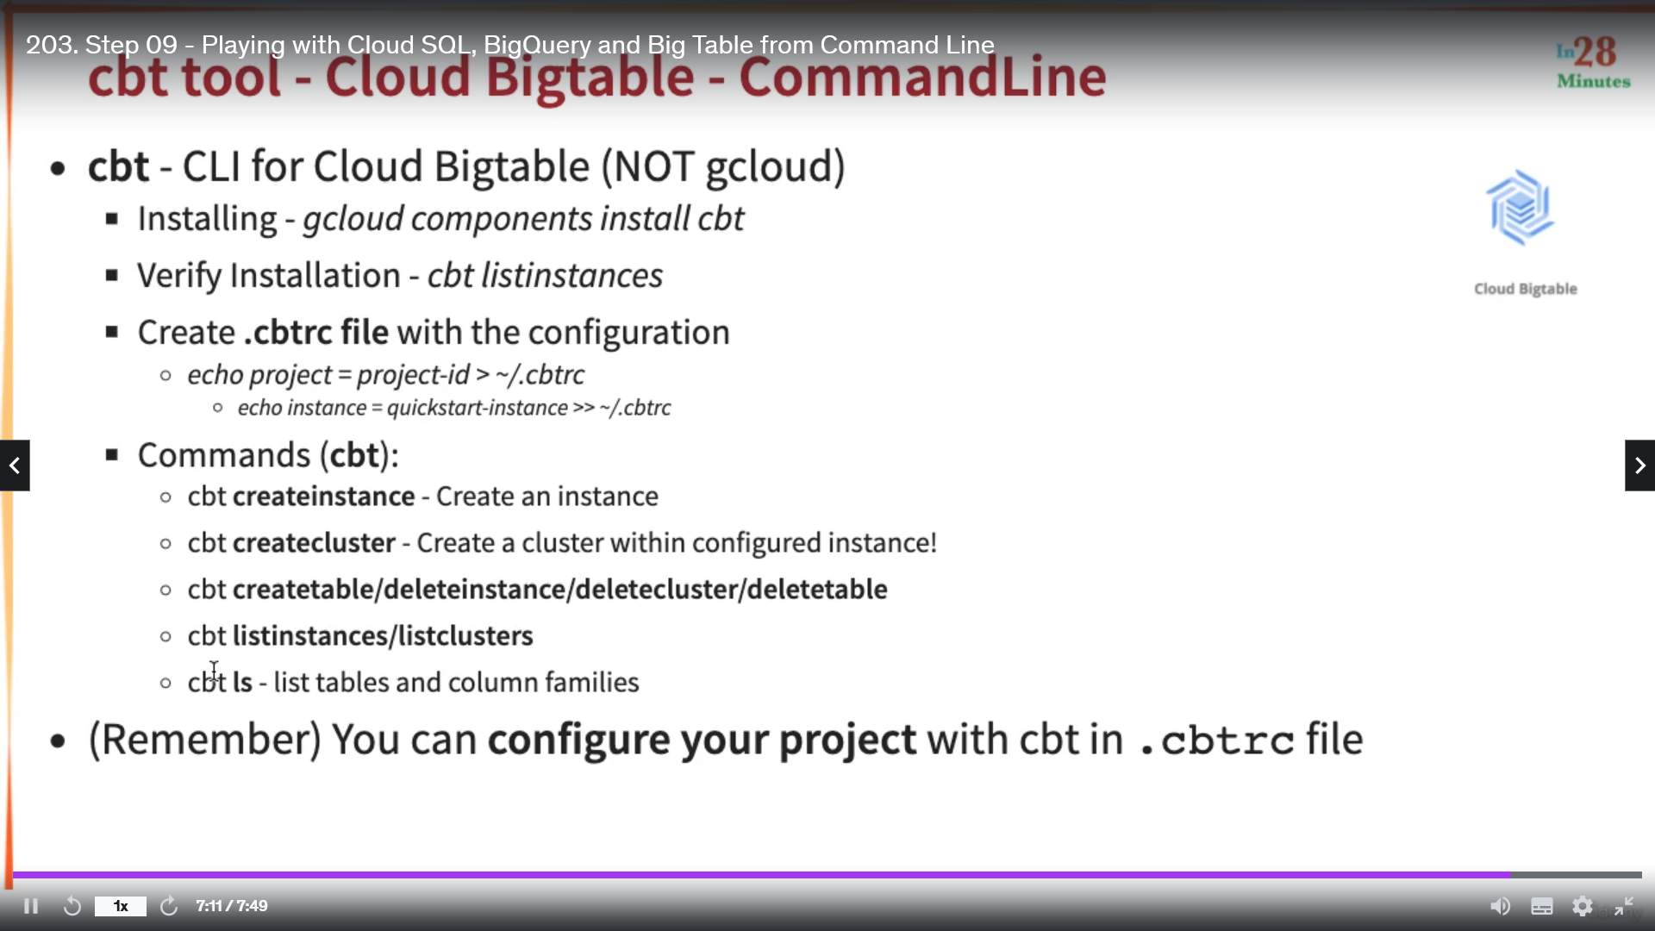

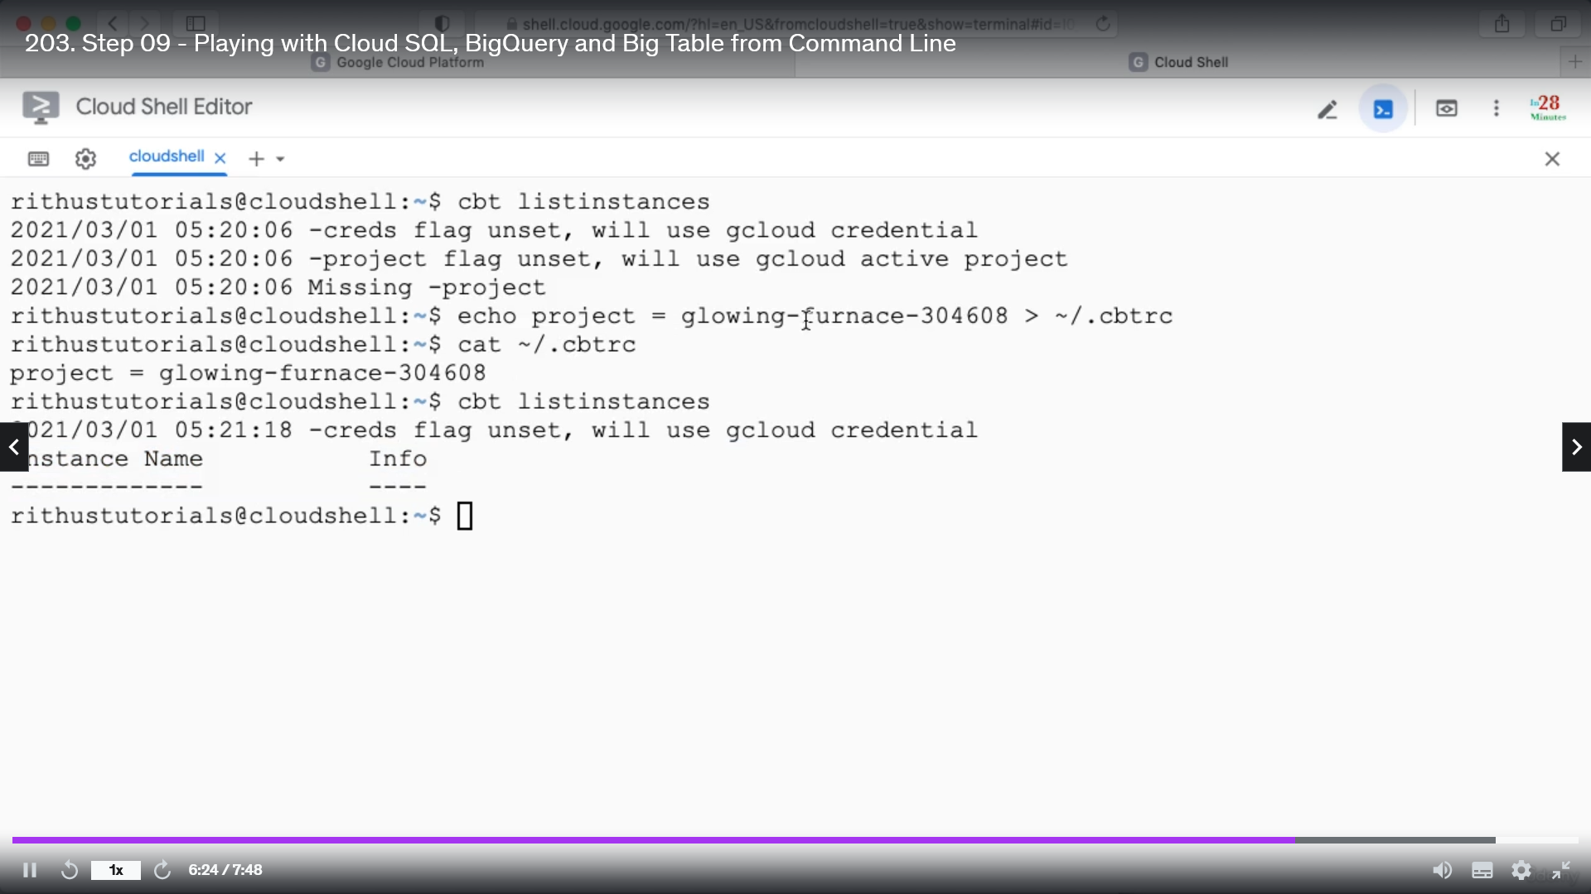

Importing and Exporting Relational DB

This import or export happens from cloud storage. 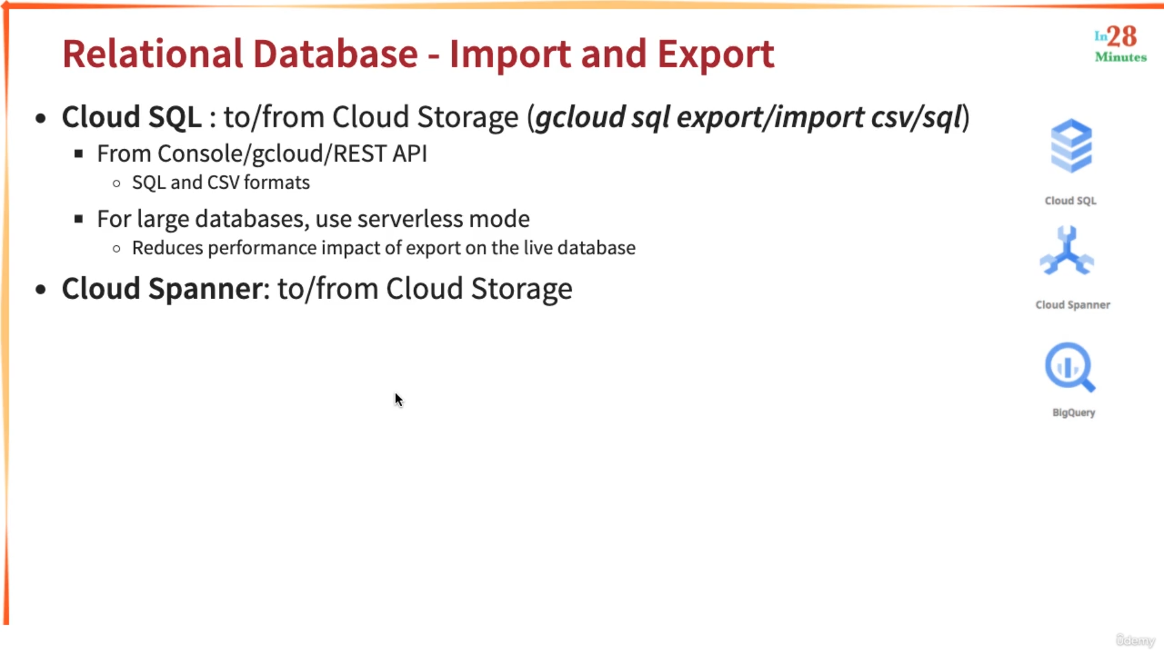

Serverless mode creates a standby db from the actual db, so that the performance of the actual db will impact less.

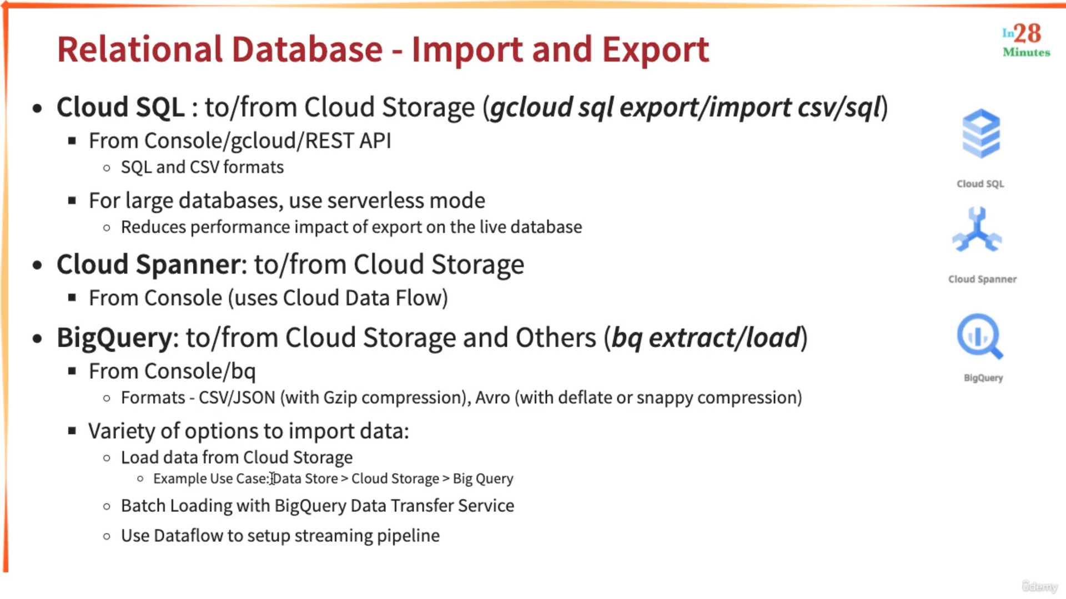

Data flow is used for streaming and batch data.